4. S24CSEU1905@bennett.edu.in , S24CSEU1912@bennett.edu.in , S24CSEU1916@bennett.edu.in

5.Aditya Kumar Sinha , Nisidh kumar , Raj Pratap Singh

6.S24CSEU1905 , S24CSEU1916 , S24CSEU1912

7. Broke-and-trade

8.

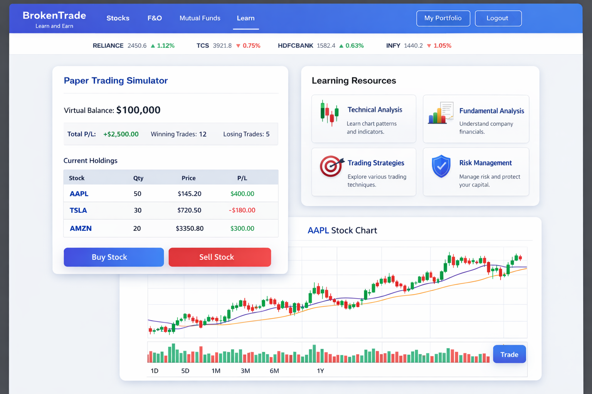
I
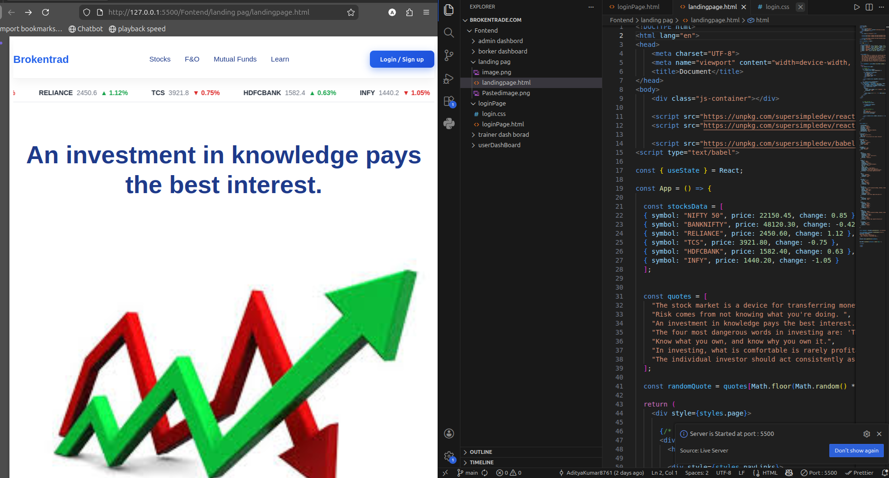
I

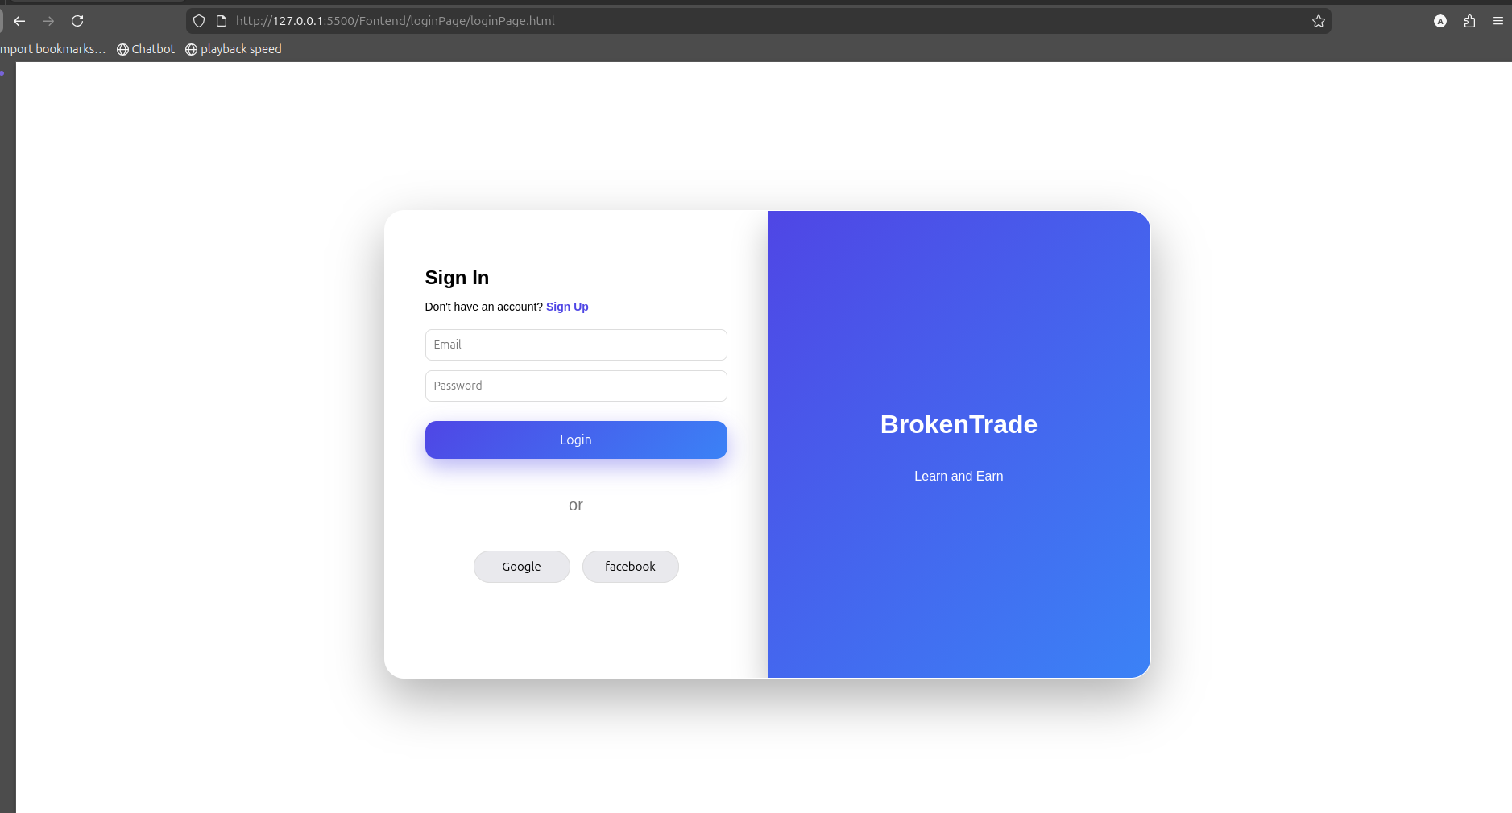
I
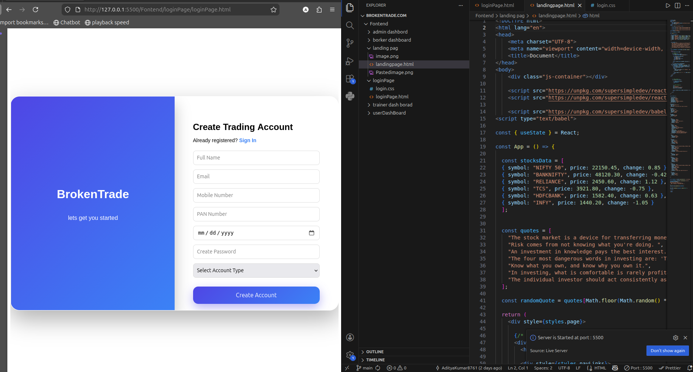
I

User Interface Design (Prototype) – BrokenTrade

BrokenTrade’s User Interface Design is developed using User-Centered Design (UCD) principles. The goal is to formulate an interface that is easy to use, accessible, and can be implemented with a beginner’s learning curve who want to start investing. The design philosophy of this website is to reduce complexity so that people without much knowledge about the financial markets can use the site easily. In addition to the landing page which provides an easy navigation with options for Stocks, F&O, Mutual Funds and Learn, the real time stock ticker and quotes allow users to stay updated on their investments. The login and account creation pages have a minimalistic layout for easy onboarding. The account creation form asks for name, email and account type. The design utilizes consistent colors, gradients and button shapes to enhance the usability and visual of the website. In addition, the design is easy to read and is responsive with a usable layout throughout the website. A different learning resource and trading exercises can be accessed from any devices. Users can practice the learning contents with paper trading with virtual money. The paper trading scenario allows users to practice trading with other exercises. The purpose of this feature is to encourage experiential learning. The design layout is user-friendly and does not require any prior knowledge of the site. The paper trading is a step-by-step interactive walk-through from learning concepts to practicing them. The landing page interface, account register page, login authenticate page and educational modules page show the user flow in the website. These interfaces are designed to reduce cognitive load and encourage users to learn more about their financial markets with low risk. Figures – User Interface Prototypes Landing page interface of BrokenTrade showing navigation and stock ticker information User login page interface. Account register page interface for creating a trading account Prototype interface for paper trading and educational learning modules

9. image pdf

10.
Potential User 1 Feedback:
The BrokenTrade platform is very user friendly and mirrors easy navigation. I prefer the neat interface and the distinct sections that include Stocks, F&O, Mutual Funds and Learn. The concept of integrating learning content with a paper trading simulator is quite handy to all beginners such as myself who would wish to have the experience of trading without involving real funds. The process of log-in and sign-up is also quite easy and uncomplicated.

Potential User 2 Feedback:
I believe that BrokenTrade is an excellent idea since numerous individuals are interested in knowing how to invest but fear losing the money at the start. The feature with paper trading will be beneficial to the users as they will learn to operate the market in a protective setting. The landing page stock ticker and inspirational investment quotes are also appealing to me. The general layout is contemporary and simple to follow.

Potential User 3 Feedback:
The platform offers a systematic method of acquiring knowledge of trading and investing. I also appreciated the fact that the site is education-oriented prior to the real trading. The learning parts including technical analysis and risk management may assist a beginner to develop a solid ground. The interface is user-friendly and therefore new users exploring the various features of the interface would not get lost easily.

Potential User 4 Feedback:
BrokenTrade appears to be a highly practical source of information to both students and amateurs who are interested in learning about financial markets. The idea of paper trading learning and practicing is highly viable. The layout of the landing page and the pages of creating an account is professional. The number of learning modules and tutorials can be increased, and this platform can become a very helpful tool to a person who is interested in trading.

Potential User 5 Feedback:
I was also intrigued by the concept of BrokenTrade since it is concerned with education as well as practice. Real trading is only possible in many trading platforms, which is why this platform praises the idea of learning in the form of educational materials and paper trading simulations before engaging in the actual trading. The interface is easy and appealing to the eyes. I believe that as a novice, I will feel free discussing this site and developing my knowledge and self-esteem.

11.
The following is a condensed version (around 500 words) that you can use to fill your form.

Design Documents

The BrokenTrade platform is designed around a scalable and modular architecture that divides the system into various functional layers in order to maintain, make the system efficient and easy to use. The site is created more as an educational and practice site where one can study concepts of investing and then practice using a simulator of paper trading without the use of real money. The architecture comprises of three key parts namely the Frontend (User Interface Layer), Backend (Application Logic Layer) and the Database Layer. All the components carry out certain functions and interact with the others via clearly defined interfaces.

The Frontend Layer refers to the user interface of the system and is what displays all the visual elements that are used by the users. It has pages like landing page, log in page, account registration page, learning modules, and the paper trading dashboard. The interface will be easy, minimal and user friendly to enable the user unfamiliar with trading to navigate the interface easily. It has navigation menus like Stocks, F&O, Mutual Funds and Learn that give users a very easy time navigating through the educational materials and trading simulation. The frontend also shows stock tickers, inspirational quotes of investment, and any other information which makes the user remain interested in financial education.

The Backend Layer deals with the essential logic of the system and removes the requests of the frontend. It deals with activities like user authentication, account management, user activity storage and paper trading transactions. On user login, registration, or simulated trade, the backend services the request and interacts with the database to save or retrieve data. This layer makes sure that all the actions undertaken by the user are taken care of safely and effectively.

Database Layer contains all the information that will be needed by the BrokenTrade platform. This contains the account information of users, progress of learning, simulated trading history and market related data in the paper trading system. Storing such data in a well-organized database allows the platform to trace the activities of users, offer personalization of the learning process, and simulated trading performance analysis.

The Use Case Diagram of the system shows the interaction of the users with the BrokenTrade platform. The key participant in the system is the user, who has the capability of carrying out a number of activities, including registering an account, accessing the system, studying learning modules, market information, and virtual money paper trades. Such interactions can be used to show the key functionalities of the platform and the interactions of the users with various features.

Activity Diagram explains the flow of the user in the system. One enters the platform by registering or logging in. Upon log in, it offers the user learning modules which educate about the fundamentals of investing and trading. After grasping the concepts, they will be allowed to use the paper trading simulator where they can practice trading with virtual funds. The system captures the simulated trades, and gives the users the option to contest their performance, and learn by making an error and go on to enhance their trading knowledge.

The Overall Architecture Diagram shows the interaction of the frontend and the backend via APIs and how the backend interacts with the database to store and access data. This multi-level architecture is designed to achieve scalability, security, and effective system performance as well as contribute to the learning and practical objectives of the BrokenTrade platform.
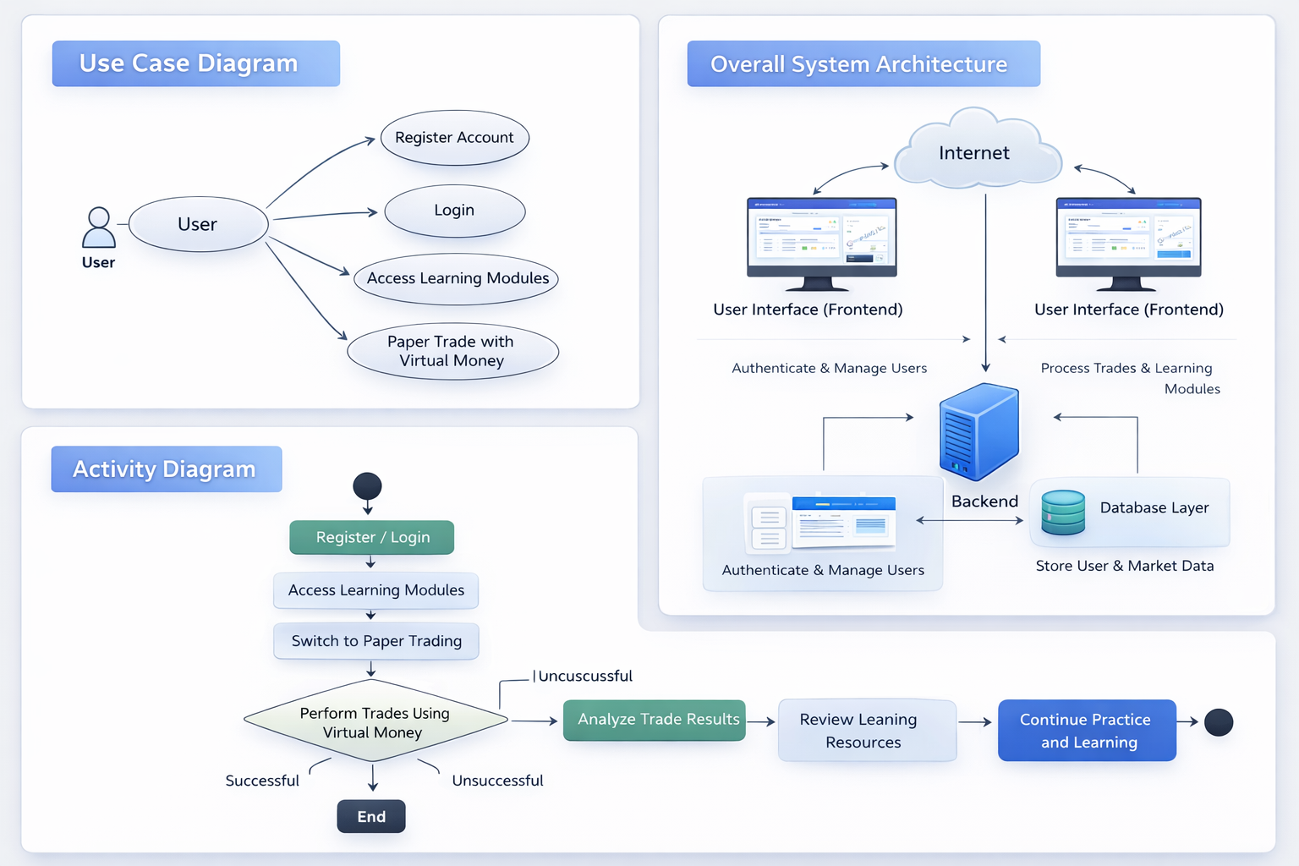
12.

13.The following is a 2000+ word version that can be included in your section of the form that is named Ethical/ Legal/ Terms and Conditions/ Privacy. containing the BrokenTrade platform.

Ethical and Legal / Privacy / Terms and Conditions

Introduction

BrokenTrade is an educational site created to assist the user with learning about investing and trading by offering them orderly learning modules and simulated trading exercises called paper trading. BrokenTrade is also designed to offer its users with a secure and experience-based learning environment where they can learn about financial markets, experiment with trading strategies, and be able to practice trading without the risk of losing real money. Through accessing or utilizing the BrokenTrade platform, users consent to accept the terms, conditions and policies as stipulated in this document. The terms are meant to safeguard the users, ethics, and transparency in the way the platform works.

BrokenTrade platform is an educational and practice only platform. It is not a financial, investment, legal or tax advisor. The terms below must be read thoroughly by users upon their use of the platform concerning ethical use, privacy, data collection, and responsibility of the platform.

Educational Disclaimer

BrokenTrade is meant to be a learning and simulation game. The information presented in this site such as articles, tutorials, examples and paper trading tools are only educational. The data found on the system is not to be taken as professional financial advice or a recommendation to purchase or sell securities.

Paper trading functionality enables users to make simulations of buying and selling of financial instruments with the use of virtual cash. The markets derived through the use of simulated trading might not result in the actual market trading outcome since real trading is associated with market conditions, cost of a transaction, emotional considerations, and other types of risks that cannot be perfectly simulated in the market.

The users should know that whatever they learn under the BrokenTrade platform is not to be recklessly used as real financial advice but should be investigated by themselves. BrokenTrade and its creators do not risk any financial losses should the users implement the strategies learnt on the platform into actual financial market.

Ethical Use of the Platform

BrokenTrade enhances ethical education and accountable application of financial expertise. The users are supposed to use the platform in good educational causes and should not perform any activities that can damage the system, other users and the integrity of the platform.

The users confess that they are not going to:

Efforts to violate or abuse the paper trading system to have unfair advantages.
Post malicious code, viruses or other harmful materials that can impact the platform.
Trying to gain unauthorized access to the accounts or confidential data of the other users.
Publicize the fake financial offers or fraudulent investment advice.
Duplicate, replicate, or transfer the platform proprietary material without any consent.

The ability to use the platform may be temporarily suspended or terminated permanently in case of any ethical usage policy violation.

User Responsibilities

It is the duty of users to keep the information about their accounts confidential. During an account creation on BrokenTrade, the user is required to give the correct and honest information. It is also the responsibility of the users to make sure that the login credentials such as usernames and passwords are not divulged to other people.

In case a user feels that his/ her account has been accessed without his/ her permission, he/ she should report the matter to the administrators of the given platform. BrokenTrade will also endeavor to protect user accounts but cannot ensure total security against unauthorized access due to negligence and ineffective security measures by the user.

It is also the responsibility of users to realize that the simulated trading performance can not be the same as the real performance and should use the platform as an educational resource instead of the performance strategy producer.

Privacy Policy

BrokenTrade appreciates the privacy of its users and is determined to keep the personal information confidential. The platform gathers as little information as it needs in order to deliver its services and enhance the experience of the user.

The platform can gather the following information when users register an account:

Name
Email address
Mobile number
Account preferences
Trading simulation data
Acquisition of learning in the platform.

The reason why this information is gathered is to deliver personalized learning, administer user accounts, and enhance the functionality of the platform.

BrokenTrade will not sell, rent, or distribute information about personal user information to third parties without the user consent unless it is necessary by law or to ensure the security of the platform.

The information about users can be stored on databases which are secure and they can be secured through normal security measures like encryption, authentication systems and secure server configurations.

Data Usage and Storage

The information retrieved out of the users can be utilized as follows:

Making the BrokenTrade learning platform accessible.
Monitoring paper trading performance and simulation.
Increasing the content and functionality of the system of education.
Carrying out a study and analysis to enhance user learning results.
Assuring security and avoiding the use of the platform inappropriately.

The platform does not exclude the collection of non-personal data (browsing data, device model, use statistics, etc.). The information is used to enhance the performance of platforms and user experience.

All the user information is kept in a secure location and no one can access it except the authorized administrators in charge of maintaining the system.

Terms of Paper Trading Simulation.

The BrokenTrade paper trading service is a feature that enables trading on the stock market using virtual funds. The site provides users with a virtual balance that they can use to purchase and sell financial instruments on the site.

Users must understand that:

Every trade that is undertaken in the simulator takes place in a virtual currency and is not real-world transaction.
The prices that will be used in the simulation of the market can be delayed, estimated, or educational prices.
The performance measures that are shown in the platform are educational analysis only.
The outcome of paper trading is not necessarily the true situation in the market.

The simulator will aim at assisting users to gain trading skills, learn how the market works, and test out their strategies without risking their money.

Intellectual Property

Any materials used in education, design tools used in the site, graphics, and software in BrokenTrade are safeguarded by intellectual property laws. The user is provided with a restricted right to access and use the platform to carry out personal studies.

The users cannot copy, republish or commercially use any content of the platform without direct authorization of the developers or owners of BrokenTrade.

The illegal copying, reproduction or distribution of platform content can lead to litigation.

Security Measures
BrokenTrade implements reasonable security measures to protect user information and maintain system integrity. These measures may include encrypted communication, authentication systems, and secure data storage.
However, users must understand that no online platform can guarantee complete security. While BrokenTrade takes appropriate precautions to safeguard data, it cannot guarantee protection against all possible cyber threats.
Users are encouraged to maintain strong passwords and follow recommended cybersecurity practices while using the platform.

Limitation of Liability
BrokenTrade and its developers shall not be held responsible for any financial losses, damages, or decisions made by users based on the information or simulations provided on the platform.
The platform is intended solely as an educational tool. Users are responsible for conducting their own research and consulting professional financial advisors before making real investment decisions.
BrokenTrade does not guarantee the accuracy, completeness, or reliability of financial information displayed within the platform.

Changes to Terms and Conditions
BrokenTrade reserves the right to modify, update, or revise these terms and conditions at any time. Changes may be made to improve platform functionality, ensure compliance with legal requirements, or enhance user protection.
Users will be notified of significant changes to the terms through platform notifications or email updates. Continued use of the platform after such changes indicates acceptance of the updated terms and policies.

Acceptance of Terms
By creating an account and using the BrokenTrade platform, users acknowledge that they have read, understood, and agreed to the ethical guidelines, privacy policies, and terms and conditions outlined in this document.
Users confirm that they will use the platform responsibly, respect the rules of ethical conduct, and understand that BrokenTrade is intended solely as an educational environment for learning investing and trading concepts.

14.
Feasibility investigations / Business setting / Monetization / Opportunity investigation.

The BrokenTrade platform is a practice and educational web application, which is structured to enable beginners to learn the concept of investing and trading through organized learning modules and a paper trading simulator. This project has a high likelihood of success since it involves the use of relatively technology-wide-spread web development tools, including HTML, CSS, JavaScript, and backend frameworks which are well-used in contemporary software development. The site is capable of being created and supported with relative amounts of technical capability and value a great deal in terms of education to those users who are interested in financial literacy and trading.

Business wise, it can be seen that there is an increasing interest in participating in the stock market particularly among the students and young professionals who wish to know about investing before they put their real money into it. The lack of learning platforms accessible to many beginners may be the root cause depending on the fact that many do not have practical experience involved with the theoretical knowledge. BrokenTrade provides a solution to this issue by committing to learning content and a trading environment simulator where users can train their trading strategies and have no financial risk associated with it.

There is also a prospect of monetization of the platform. It would have the potential to make money by providing premium educational content, trading simulation, subscriptions, or working with providers of financial education. Other forms of monetization would be advertising or affiliate relationships with brokerage services, or providing more advanced analytic tools to advanced learners.

Regarding the opportunity analysis, there is growing demand of financial education platform as more individuals are striving to become more financially literate. BrokenTrade will be able to sell itself as a non-expert-learning platform that expands the divide between theoretical learning on finance and real-life trading. The platform will be able to attract students, aspiring investors, and people who would like to train before moving to real financial markets by offering them organized learning materials and risk-free trading simulation.

15.
Project Cost Estimation

The development and maintenance cost of the BrokenTrade platform estimated to be used in three years comprises of costs involved in development, infrastructure and maintenance. A simplified version of Cost estimation model based on COCOMO model suggests that labor is the key cost element. In case the project is developed, tested and maintained by one or two developers, the range of labor cost will be between [?]3, 00,000 to [?]5,00,000 within the project period. This will involve time taken to design the user interface, build the logic on the back-end, and incorporating the paper trading simulator as well as the maintenance of the system.

Other expenses are software and development tools that can consist of hosting services, version control platforms, and development environments. Based on the magnitude of usage and traffic, cloud computing and server infrastructure could require around [?]30,000-[?]60,000 within three years. Hardware expenses including development laptops and testing equipment can also contribute approximately [?]80,000-[?]1,00,000 in case new equipment is needed.

Other costs might involve the registration of domains, hosting of a database, security services and maintenance support and are estimated to be approximately [?]20,000-[?]40,000 through the project lifecycle. All in all the estimated cost of developing and maintaining the BrokenTrade platform over three years is between [?]4,30,000 and [?]6,00,000 based on the use of infrastructure, development time, and the scaling.

16. https://github.com/AdityaKumar8761/BrokenTrade.com

17 .
Both answers are prepared to be pasted into your form below.
The characters in each week are 300+ which fulfills the requirement.

Weekly Reports / Diary / Progress.

Week 1
The concept of the project BrokenTrade was developed in the first week. The primary aim of the project is to develop an educational platform in which users can also learn about investing and trading as well as practicing in a paper trading simulator. Existing financial education platforms were subject to research to get an idea of their characteristics and weaknesses. It was started with notes on the requirements, potential features, and target users coded in Google Docs to monitor the progress and organize the development.

Week 2
During the second week, the plan was to plan the system structure and project workflow. The fundamental design of the platform was explained, that is frontend, backend, and database. Primary UI wireframes were developed on the landing page, signup page and the login page. Elements of navigation like Stocks, F&O, Mutual funds and Learn were structured to categorize educational content and enhance the user navigation in the site.

Week 3
In week three, the frontend interface was started to be developed. To provide an imitation of a real financial setting, the landing page design adopted a navigation menu, branding, and a stock ticker to mimic the stock market. It was developed in a manner that was simple and easy to understand since the design was targeting the beginner user. CSS style manipulations and layouts were also done to enhance visual presentation.

Week 4
User authentication interfaces were developed in week four. Login and sign up pages were created to offer the user of the platform the chance to create an account and enter the platform. The information that is collected in the account registration form includes name, email, and account details. Page validation and page navigation were also tested to make sure that one can easily make an account and log in without misunderstanding.

Week 5
In week five, the user interface and design consistency was improved. Themes of colors, gradient, and lettering had been perfected to render the platform appealing to the eyes. There were other sections that were to be incorporated on educational resources where users can get to learn the basics of investing, trading as well as risk management. This was aimed at creating a platform that is educative and interactive.

Week 6
During week six, the paper trading feature was developed in concept and the workflow of the paper trading was planned. It was meant to enable the users to experience stock trading with virtual money. Early designs were developed to show how the users are going to purchase and sell the assets in the simulator. The feature will enable novices to approach trading strategies without investing actual money.

Week 7
In week seven, testing and debugging actions were done. Page navigation was also tested to make sure that there was a smooth transition between the landing page, the login page, and the signup page. Less serious interface problems were fixed and the general usability of the platform was enhanced. The design and system architecture was also to be documented.

Week 8
The eighth week was dedicated to the review of the current development of the BrokenTrade platform. Interfaces prototype, system of user registration and structure of learning platforms were tested. Further reports such as diagrams, feasibility study, and cost analysis were drawn. It was also found that future upgrades like a better paper trading system and analytics could be improved.

Weekly Projection of the remaining time.

18.
Week 9
In week nine, the attention will be paid to the creation of the back-end of the BrokenTrade platform. The backend will be used to authenticate users, manage their accounts and also to communicate between the user interface and the database. They will be developed APIs that save user data and use the trading simulation data. Early database designs will also be installed to control the user accounts and activity logs.

Week 10
The paper trading simulator will start being developed in week ten. The users will be given virtual money to practice the process of purchasing and selling financial assets. The system will mimic trading activities and recalculate the portfolios of the users depending on the activities of the user. It seeks to build a realistic but straightforward simulation to enable users to know how to behave in the market and the decision to make when in a market.

Week 11
More learning modules will be incorporated into the platform in week eleven. There will be the addition of content associated with the basics of investing, technical analysis, risk management and trading psychology. The user interface also will be improved to make sure that learning resources are accessible and understandable to the beginner users.

Week 12
During the last week, system evaluation and testing will be performed. The platform will undergo testing that the features have been tested to be functional, such as, the feature of logging in, registering as a user, learning modules, and simulation of paper trading. Before the final project submission, bugs will be fixed, improvements done in the performance and lastly final documentation will be done.

You can also have me write two final sections which are the usual questions of professors, although you may want to do those, too:

Future Scope of the Project (very important)
Conclusion of the Project

These tend to provide additional marks in software engineering reports.

19. https://www.linkedin.com/posts/aditya-kumar-573845312_webdevelopment-fintech-tradingeducation-activity-7438876851369922561-bANW?utm_source=share&utm_medium=member_desktop&rcm=ACoAAE-AqOcB2FpUazvBKsLXr5vZGIfoKuB6D9U

20. NO

21. 22.
Aditya Mishra
E23CSEU0579
adityamisra296@gmail.com
The platform provides a structured way to learn trading and investing. I liked how the website focuses on education before actual trading. The learning sections such as technical analysis and risk management can help beginners build a strong foundation. The interface is simple, which makes it easier for new users to explore different features without confusion.

23. 24.
Divyom Agarwal
E23CSEU0586
E23CSEU0586@bennett.edu.in
BrokenTrade seems like a very helpful platform for students and beginners who want to understand financial markets. The concept of learning and practicing with paper trading is very practical. The design of the landing page and account creation pages looks professional. With more learning modules and tutorials, this platform could become a very useful resource for people interested in trading.

25.26.
rohan rathor
E23CSEU0783
E23CSEU0783@bennett.edu.in
I found the idea of BrokenTrade very interesting because it focuses on education along with practice. Many trading platforms only allow real trading, but this platform encourages users to learn first through educational content and paper trading exercises. The interface is simple and visually appealing. I think beginners will feel comfortable using this platform to build their knowledge and confidence.

27.28. 88129aditya.com 8812971661
The BrokenTrade platform looks very beginner-friendly and easy to navigate. I like the clean interface and the clear sections such as Stocks, F&O, Mutual Funds, and Learn. The idea of combining learning material with a paper trading simulator is very useful for beginners like me who want to practice trading without risking real money. The login and signup process is also simple and straightforward.

29. 30. saritarampur129@gmail.com 7002794165

I think BrokenTrade is a great concept because many people want to learn investing but are afraid to lose money in the beginning. The paper trading feature will help users understand how the market works in a safe environment. I also like the stock ticker on the landing page and the motivational investment quotes. The overall design is modern and easy to understand.

